**LAKE WENATCHEE FIRE AND RESCUE AUXILIARY**

**14193 Chiwawa Loop Road, Box 3**

**(509-763-3034)**

**Membership Meeting Minutes**

**November 8, 2023 – 6:00 p.m. at Station 91**

**Board members present**: Jim MacMillan, Dorothy Baker, Barbara Harris, Liz Gilbertson, Scott Baker, Audry Henniger, and Elizabeth Pollock.

**Welcome:**  Jim MacMillan

**Pledge of Allegiance**

In honor of Veteran’s Day, military members were asked to stand and were thanked for their service.

**LWFR District 9**:

**Chief Walker**:

Mike Payne won the Fire Commissioners spot for the next 6 years. Congratulations Mike!

It is our slow time of the year, and we are doing budgets, 2024 planning, and Incident Command Officer training. All our Commanders are going through this and it’s 40-50 hours of training.

A chassis has arrived for our new tender and the delivery will be in April or May. It was from a grant from FEMA and some money from the Auxiliary that paid for this new tender.

Electric cars have specific issues when they catch on fire, and we are learning that they are difficult to put out. Sometimes the cars are just left to burn but sometimes this is not possible. We are purchasing 2 tools to use with EV’s: A plug that disables the car; and a silica blanket which is fireproof and helps contain and smoother the fire. Each blanket costs about $1500, and the plugs (with adaptors) are about $900.

**Call to Order:** Jim MacMillan called the meeting to order at 6:12 p.m.

**Attendance:**  56 members attended in person plus 10 members via Zoom, and 2 guests.

**New Member/Guest Introductions:**

Kim Jones

Mitch Eggers

Cherie Griffith – first meeting.

Nancy Barga - first meeting.

Welcome Kim, Mitch, Cherie, and Nancy!

**Approve October Minutes:**

Elizabeth let the membership know that there was one correction from the October minutes they received.  Mitch Eggers was at the October meeting but was not listed as a guest.  This has been corrected in the minutes that will be put on the website.

Randy Pollock moved to approve the October meeting minutes, seconded by Bob Sage and the motion passed.

**October Treasurer’s Report: (Barbara Harris)**

Memorial Account $230.00

General Account

Beginning Balance September 30, 2023 $75,184.44

Yard Sale Donations +$ 140.00

Yard Sale Expenses -$ 443.22

Yard Sale Expenses -$ 60.61

Postage Stamps -$ 26.40

Ending Balance October 31, 2023 $ 74,794.21

April Adamson moved to approve the October Treasurer’s report, seconded by Franklin French and the motion passed.

**Committee Reports:**

**Nominating Committee - Jim**

There are 4 people on the nominating committee so far (Jim MacMillan, Liz Gilbertson, Jimi Wilson, and Stan Morgan) and Jim asked the membership if anyone else would like to be part of it. Jen Norris volunteered to be part of the committee.

**Old Business:**

**Zoom Account and Equipment: Audry**

We are going to use my Zoom account (which is free to the Auxiliary), and we are using Station 91’s equipment. Therefore, we will not be spending any of the money that was previously voted on for Zoom equipment.

**Yard Sale:**

Thank you to everyone who provided feedback as it helps the Yard Sale evolve every year. The feedback was compiled and sent to Velda.

**Upcoming Events:**

**Squirrel Tree Benevolent Day: November 14th**

Benevolent Day at the Squirrel Tree is Tuesday, November 14th from 8:00 a.m. to 9:00 p.m. There will be an Auxiliary picture board at the entryway, an information sheet at each table giving information on the Auxiliary, and a donation boot at the cash register. There will also be a QR code which will take people to the Auxiliary website if they would like to donate online. Everyone is encouraged to attend to support the firefighters and proudly wear their Auxiliary swag. A reminder of the event will be sent out the day before.

**Pancake Breakfast – December 2nd: Dorothy**

Flyers and banners are up at local retailers and a flyer is on the Auxiliary Facebook page. Please like it, share it and comment on it. The Plain school will get flyers for the kids to take home. In the past, we have given coupons to the Pantry but, last year, no families used them. This year we will give the Pantry coupons along with some raffle tickets for the family to use. If you would like to donate some raffle tickets to these families, there is a basket just outside the door.

From the feedback last year, this year there will only be 1 cashier station where people can buy both breakfast and raffle tickets. There are 10 vendors this year and vendor and cookie sales will be separate cashiers. As parking is limited, would you please consider carpooling or staggering your arrival time. Velda will confirm if volunteers can park at Midway.

A big thank you to Stan Morgan and Scott Baker for doing a great job getting donations for the raffle baskets. Raffle tickets are on sale tonight and a few baskets will be on display at Plain Grocery where you can also buy tickets. Raffle basket wrapping is on November 18th at the Rec Center.

If you forgot what you signed up for at the Pancake Breakfast, it is shown on the door at the back of the room. If you would like to volunteer, then just add your name to the list. Sharyl Nelson to give Shawna Presley candy canes for the Santa House. Elizabeth Pollock volunteered to be the second money counter at the event.

**January Meeting – Chili Cookoff Contest:**

The Social Committee has planned a chili cookoff contest at the January meeting and details will be sent out prior to the meeting. There will be a prize awarded for the best chili.

**New Business:**

**50th Anniversary Volunteers:** Jim

Looking for volunteers to be on the LWFR/Auxiliary committee to plan anniversary events in 2024. Please let us know if you would like to be part of the planning.

**Co-Chair Food Support:**

Kathleen Colvard is the new co-chair for the food committee.

**Code of Conduct: Jim MacMillan**

Jim read through the Code of Conduct wording to remind all members of it.

**Online Auxiliary Clothing: Chris King**

The clothing orders should be here on Monday, and if they are, the clothing will be available at the basket wrapping event next Saturday, November 18th.

**Safety Preparedness: Marcia Scott**

With winter approaching and the likelihood of power outages and hazardous driving conditions, these three items are great to have.

Scrubzz Bath Sponges Emergency Warning Triangles

The Ecoflow Solar Powered Generator

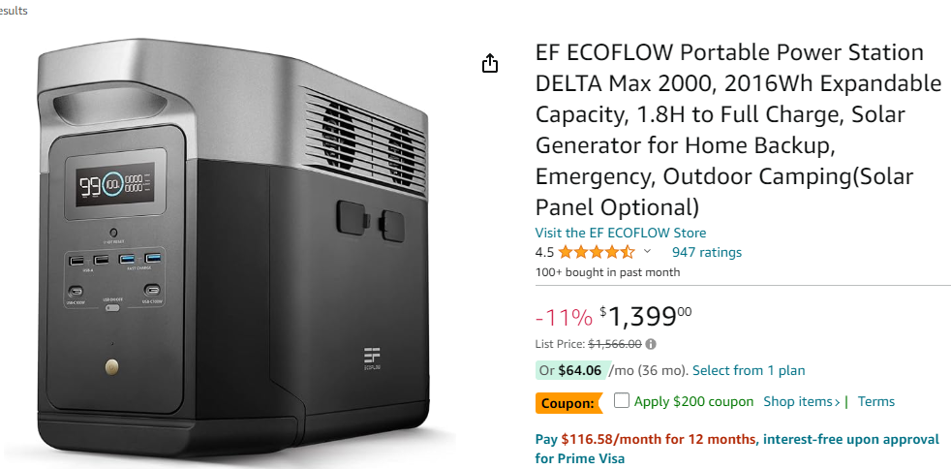

**Sunshine Report: Sharyl Nelson**

A card was sent to Donna Malcevski. If you need a card sent out, please let Sharyl know.

**Good of the Order:**

Marilyn Mylius suggested that the Rec Club, Ponderosa, and the Auxiliary do a joint Easter Egg hunt for the kids at the Rec Club. This will be discussed further in January.

Fire Station 92 in Chiwawa Pines is all decorated for the Holidays. Thank you, Scott Baker!

There are new member folders available from Elizabeth Pollock if you are new to the Auxiliary.

Kris King will look into why the electronic new member form is not working and will also let us know if anyone applied via this method.

**Pie Contest Winner:**

Thanks to everyone who participated in the Pie Contest and the winner is Chris King with the rum apple pie. Congratulations Chris!

Elizabeth to send out the recipes.

**Next Meeting:**

The next Auxiliary meeting is on Wednesday, January 10th, at Station 91 at 6:00 p.m. and a Zoom option will be available.

Fred Guimond moved to adjourn the meeting, seconded by Stan Morgan, and the motion passed.

The meeting concluded at 6:53. p.m.

**Note:**

If you want to look at past minutes, they are located online, and the path is below:

LWFR.org: About LWFR: Auxiliary; Member Login (bottom of page); Auxiliary Login; Password is **Auxmember18**; Minutes. It shows minutes since 2010 along with the Bylaws and Articles of Incorporation.